JANUARY 2024
NEWSLETTER
CITY OF LINCOLN
74 Santee Road

Office 258-7969
Police 258-2403
Emergency 911

City Hall Office Hours
Monday-Friday 7:30 AM-5:00 PM
Friday 7:30 AM-12:00 PM
www.cityoflincolnnd.com
Please follow our Facebook page any city updates will be posted here first.
www.facebook.com/cityoflincolnnd
Please remember to contact the city office if you are starting/stopping utility service, would like to start automatic payment for your utilities, need a replacement or extra garbage tote, or if there is a streetlight out. Also, if your phone number changes since we use these contacts in case of emergencies.
Council Members:
Mayor: Keli Berglund
Keli.berglund@cityoflincolnnd.com
Carrie Praska: Financial
carrie.praska@cityoflincolnnd.com
Jaime Leingang: Public Works
jaime.leingang@cityoflincolnnd.com
Amanda Davis: Beautification
amanda.davis@cityoflincolnnd.com
Ryan Glass: Public Safety
ryan.glass@cityoflincolnnd.com
MEETING DATES
Planning & Zoning: January 23, 7:00 pm
City Council: January 4th & 18th
EDC: January 25th
Park Board: 3rd Tuesdays at the Park Shelter-32 McDougall Drive 6:00 pm
Tree Board: January 3rd
To place an item on the agenda, contact a City Council Member or The Mayor at least one week prior to the meeting.

************HAPPY NEW YEAR************


PET LICENSES
The City Office
has 2024 Tags.
ANY pet 6 months and older needs to be licensed annually.

If your recycling tote is found to have contaminates it will NOT be picked up. TransTrash has had to trash multiple loads of recycling due to continued abuse.
NO PLASTIC BAGS/STYROFOAM/PLASTIC WRAPPING
NO YARD WASTE

DECEMBER 2023 BILLS
Acme Tools $3,497.14, Advanced Business Methods $423.50, Aire-Master $87.75, Axon Enterprise $6,072.07, Bismarck Tribune $1,023.40, Burleigh County Recorder $2.00, Burleigh Morton Detention Center $525.00, CHI St. Alexius $250.00, City of Bismarck Dispatch $3,971.00, City of Bismarck $1,707.80 Dakota Awards $24.99, Electronic Communication $5,913.00, Guardian Lock $3.21, I-State Truck Center $168.03, Elizabeth Kapp $197.03, Just Fur Pets $220.00, Keith Knoll $173.39, Lexipol $6,300.67, Lincoln Auto Repair $192.20, Lincoln Park Board $8,245.44, Linde Gas $172.40, Missouri Valley FOP $135.00, NAPA $51.98, ND Dept. of Health Chemistry $325.17, ND Dept. of Health Microbiology $300.00, ND Rural Water $721.00, Northwest Tire $343.02, Office of State Auditor $35,611.94, One Call Concepts $10.40, O`Reilly Auto Parts $23.77, Presort Plus $885.04, River City Heating $1,479.90, Runnings $25.57, SEH $20,033.01, April Stone $140.00, Sweeny Controls $4,650.00, Tri Energy $2,495.28, Uniform Center $97.98

PUBLIC WORKS
Snow Removal: All trailers and campers need to be removed from the streets by Nov 1st. With snow coming we ask that residents not park on the street so the city plows can clean the streets. Please keep garbage cans on your driveway instead of on the street, this makes it easier for snowplows to get through.
EPA requires all cities to inventory their water service lines within your homes. The city is asking you, if capable, to take one picture of the inlet and outlet of your meter and email the picture with your address to admin@cityoflincolnnd.com or drop it off at the city office. If you’re not capable of taking the picture, please contact the city office at 701-258-7969. I have attached a couple pictures to help assist in taking the correct pictures. 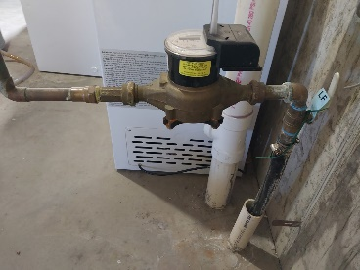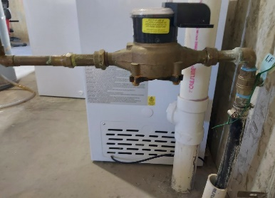
Additional information about the Lead and Copper Rule Revisions can be found at https://deq.nd.gov/MF/DWP/LCRR/ Terry Schutt, Public Works Director


SAFETY CIRCLE
Prepare Your Home (CDC)
Staying inside is no guarantee of safety. To keep your home safe and warm during the winter months.
- Winterize your home.
  - Install weather stripping, insulation, and storm windows.
  - Insulate water lines that run along exterior walls.
  - Clean out gutters and repair roof leaks.
- Check your heating systems.
  - Have your heating system serviced professionally to make sure that it is clean, working properly, and ventilated to the outside.
  - Inspect and clean fireplaces and chimneys.
  - Have a safe alternate heating source and alternate fuels available.
- If you do not have working smoke detectors, install one inside each bedroom, outside each sleeping area, and on every level of the home, including the basement. Test batteries monthly and replace them twice a year.
- Prevent carbon monoxide (CO) poisoning emergencies.
  - Install a battery-operated or battery backup CO detector to alert you of the presence of the deadly, odorless, colorless gas. Check or change the battery when you change your clocks in the fall and spring.
  - Learn the symptoms of CO poisoning: headache, dizziness, weakness, upset stomach, vomiting, chest pain, and confusion.

LINCOLN POLICE DEPARTMENT
Total Criminal Charges for November- 23
Total Calls for Service in November 338
Total Calls for Service for 2023 - 3,740
Proudly serving you,
Robyn Krile, Chief of Police

MAYOR’S MESSAGE

January brings the beginning of a new year and puts 2023 in the past. I can’t thank enough the city’s dedicated staff at Public Works, Administration, and the Police Department. This team is amazing. Rather than reviewing 2023, let’s focus on the future. While responding to citizen requests is paramount, the key initiatives for me going forward include:
• a thorough review and cleanup of the city’s ordinances,
• obtaining a designated zip code so we can increase sales tax revenue for Lincoln,
• working with the Metropolitan Planning Organization (MPO) to create a highway on 66th to accommodate increased traffic, and
• planning for a future downtown area.
I am committed to working with the City Council and with residents. Lincoln is a wonderful community because of the contributions of every resident, and I am very proud to represent this city we call home.
Thank you and Happy New Year!
Mayor Keli Berglund

CITY NOTES
*The City of Lincoln now has an App. Go to your App store and type in Lincoln ND.
* Minutes from the Council Meetings can be found on the City of Lincoln ND website.
* All weather-related updates will be posted to The City of Lincoln website as well as The City of Lincoln Facebook page.
*2024 Election Packets are available at the office.
*We now have the option to pay by ACH/E-Check with DOXO. The link is on the City of Lincoln Website.
* The 2016-2021 Audit report is available on the ND Office of State Auditor website.

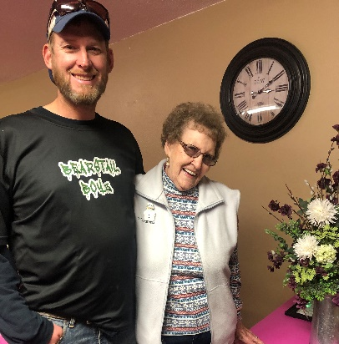
‘Lincoln Park Board Member, Brock Garaas, celebrating his grandmother Verlee Snyder’s 90th here in Lincoln. Happy Birthday Verlee!’

