February 6, 2024
Dear Lincoln Resident,
We are writing to inform you of a critical initiative directly impacting the safety and well-being of our community. The Environmental Protection Agency (EPA) and State of North Dakota (State) require every Public Water System in the state to complete a Water Service Line Inventory for their community to comply with federal and state requirements.
Our community is committed to ensuring the safety of our residents. Lead is a toxic metal and can negatively affect your health over time. Our commitment involves complying with these regulations to ensure that if any lead is present in our system, it is immediately identified and removed. The EPA established specific regulations to reduce lead exposure in communities and protect public health, which involves creating an inventory of all water service line materials throughout our distribution system. This inventory is not only a proactive measure but a legal requirement that aligns with both federal (EPA) and State regulations.
Key points to consider regarding the importance of the Water Service Line Inventory:
- Protecting Public Health: Identifying and replacing lead service lines is crucial for safeguarding the health and wellbeing of our community.
- Compliance with Regulations: The EPA and State have set specific inventory requirements. Compliance with these regulations is mandatory to ensure our community meets the highest standards for water quality and safety.
- Access to Funding: Many federal and state programs offer financial assistance to communities actively working to replace lead service lines. Your assistance will allow us access to these funding opportunities and expedite the replacement process.
We Need Your Help!
Our mission is to accurately inventory our entire system using the most cost-effective and least intrusive methods possible. We strongly encourage you to provide pictures and any information you have on your property's plumbing materials, so we can inventory your service line without having to enter your home, pothole, or dig a trench in your yard. Thank you to the 291 people who have already sent in pictures of their water service lines.
Burian and Associates was hired by the State to assist Lincoln with completing our Water Service Line Inventory. On the next page is an ideal example of the photo submission we are requesting. Additionally, there is an attached flyer from Burian and Associates guiding you through identifying your own water service line location and materials.
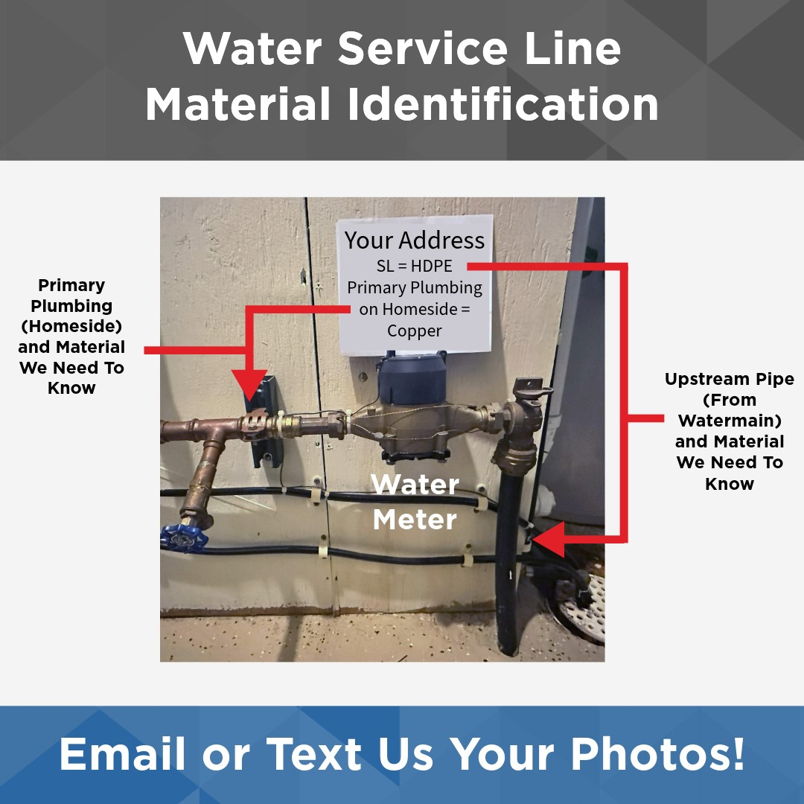
If possible, please include a sign with your submission (as shown above).

Pictures can be emailed to: Admin@CityofLincolnND.com or text them to 701-391-5808. Please include your name and address in the submission so we can properly account for your specific property/service line.
We understand that this process may raise questions and are committed to keeping you informed every step of the way. Public works is available to assist with any questions and if you would like to schedule a service line assessment, please call our office at 701-258-7969.
Thank you in advance for your commitment to helping our community stay safe!

City of Lincoln

Additional Resources and Information can be found here:
*Self-Identify your Service Line Material Guide: https://apps.npr.org/find-lead-pipes-in-your-home/en/#intro
*EPA Lead and Copper Rule Information: https://www.epa.gov/ground-water-and-drinking-water/proposed-revisions-lead-and-copper-rule
*NDDEQ – State specific information and resources: https://deq.nd.gov/MF/DWP/LCRR/

